Response letter for the review of: **Design of the Full Scale Experiments for the Testing of the Tensile Strain Capacity of X52 Pipes with Girth Weld Flaws under Internal Pressure and Tensile Displacement**

Dear Editor,

We thank the reviewers for the detailed and careful observations and recommendations for our paper. We have modified the manuscript and have taken the observations and notes into consideration. Below is a detailed response to the reviewers’ comments. The reviewer comments are listed in **boldface**.

Reviewer 1:

**I find the 1OD style very confusing –it is not clear if you mean 10 diameters or 1 outside diameter. I would suggest just using 1D as the difference between outside and mean is not really significant.**

We thank the reviewer for pointing the confusion out. We have made the following replacements:

“1OD” was replaced with “1-OD”

“6OD” was replaced with “6-OD”

“0.1OD” was replaced with “0.1-OD”

**Overall, the authors should decide whether this paper is a description of their experimental**

**techniques, or an analysis of the behaviour of X52 pipes. I don’t think there is sufficient data for the**

**latter (only one test) so it should concentrate on the techniques.**

We have added the results of one more test to our paper and now we believe there is sufficient data for the both, the experimental technique and the analysis of the effect of internal pressure on the behaviour.

**The FEA description needs to be expanded as it is not clear why the agreement**

**with experiments is so bad. It is also not clear why non-linear (?) FEA was needed to size the welds joining the tube to the end plates when a simple force / area calculation would have sufficed for a standard design problem.**

We thank the reviewer for their insightful comments. We have expanded the FEA section to include more details and justification for the use of FEA.

**No pressure correction factor in EPRG Tier 2. Please give reference to EPRG Tier 2.**

We thank the reviewer for indicating this deficiency in the text. The pressure correction factor was introduced by the researchers at the University of Ghent instead of the EPRG Tier 2 guidelines. We made the following correction in the text and added the reference to the corresponding research:

*“Furthermore, Verstrate et al [9] introduced a pressure correction factor of 0.5 in order to include the effect of internal pressure in the tensile strain capacity predictions in a conservative way”*

**Comment about Table 2: Are these measured properties ? If so the yield is not SMYS. Specified is not measured. Both yield and tensile are below specification values**

We thank the reviewer for indicating this deficiency in the text. The values in Table 2 are based on measured stress strain curves. We have modified the text in the table and removed the word: “SMYS”

**Give more detail on the FEA: Shell or brick elements ? Elastic or elastic – plastic ? Linear hardening or measured stress strain curve ? Why model the bolts + plate when you rigidly tie the holes to the pin. Meshing of the flaw area ?**

We thank the reviewer for indicating this deficiency in the text. We have expanded the FEA section and added a comparison between the FEA and the experimental results.

**ASTM A490 is a specification for the bolts as a material. It does not give safety criteria because it is a design code. Please discuss.**

We thank the reviewer for pointing out this discrepancy in the text. The following additions and changes have been made in section 1.2 to clarify this point:

*“The maximum allowable tensile stress for 1 inch (25.8mm) diameter ASTM A490 bolts is equal to 1040 MPa. The factored tensile force due to the applied tension and bending per bolt is required to be less than the specified maximum force:*

$$f_{t}={\left(f_{t}\right)}_{T}+{\left(f_{t}\right)}_{BM}=\frac{\sum{RF}}{n⋅A_{b}}+\frac{\sum{RF⋅e⋅c}}{I}<1040 MPa$$

*where ${\left(f_{t}\right)}_{T}$ and ${\left(f_{t}\right)}_{BM}$ are the tensile stresses due to tension and bending moment respectively. $A_{b}$ is the cross section area of one bolt and $n$ is the number of bolts. $\sum{RF}$ is the total eccentric force acting on the end plate, $e$ is the amount of eccentricity, $c$ is the distance from the pipe axis to the center of the most distant bolt and $I$ is the total moment of inertia of the bolt cross section areas. By choosing $n=14$, the chosen bolt satisfies the above requirement.”*

**Comment about Figure 16: This needs replacing as I can’t really understand what is shown. At the least put an arrow to a transducer.**

We thank the reviewer for pointing out this missing part in Figure 16. We enclosed the cable transducers and the strings connecting them to the pipe in red boxes. The new version of Figure 16 is shown below.

|  |  |
| --- | --- |
|  |  |

Figure 16: Steel column and cable transducers

**Comment about the CTOD/CMOD curve (Figure 19): I don’t believe you had a crack tip opening displacement of 12 mm with no load. Remove your clip gauge zero reading. Also you have measured CMOD – crack mouth opening displacement – not CTOD.**

We thank the reviewer for indicating this deficiency in the text. The zero readings are removed from Figure 19 and CTOD is replaced with CMOD. The new plot is shown below.

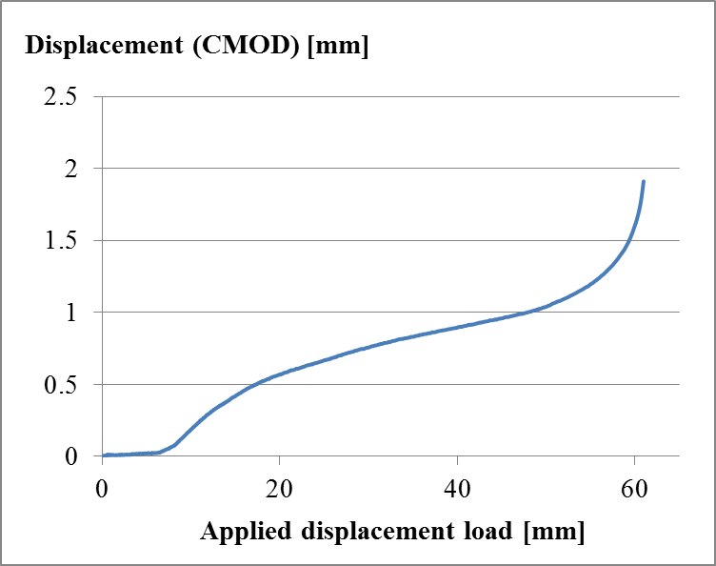

Figure 19: Variation of CMOD with respect to the applied displacement

Reviewer 2:

**The physical testing appears to be well done, with good correlations w/r to theoretical. However, the Discussion/Results section needs to be rewritten and shortened. The actual result was hidden in the section.**

We thank the reviewer for indicating this deficiency in the text. We have rewritten many parts of the paper and we hope that it is more clear now.